Male and Female Perception of Taboo in Aceh Language

(Gender Perspective)

Maria Ulfa¹, Mulyadi², Mhd.Pujiono³,Khairina Nasution⁴
Universitas Sumatra Utara, Medan, Indonesia,
E-mail: mariaulfa.fkip@unsam.ac.id

Abstract
This research needs to obtain how male and female perspectives on tabu language. This study used qualitative research with a phenomenology approach. There are fourteen subjects in this research that consist of seven males and seven females, the age of the subject is categorized start from early adulthood to middle adulthood. The researcher used observation and gave questionnaires to find the data. The result of this research found that; 1) Among males and females ever use taboo language but the most frequently used taboo language is male. Male use more frequency taboo than females, most males said that they ever used taboo about 57 %, in comparing to females 14 % percent used taboo language in daily communication. 2.) A taboo language is used by an adult is very limited, adults-only know about the taboo related to dirty words and insults, which means that taboo that understands by an adult is shifting in believing and practicing. 3) Male and Females have the same perspective toward taboo language, Most females believe that taboo is impolite words and a kind of rude in Male perspective taboo is impolite words

Keywords: Taboo Language; gender Perspective; Male and Female

- Introduction
Taboos are a feature of every culture (Qanbar, 2011), and they are seen to be the source of social issues (Allan and Burridge, 2006). In many circumstances, a taboo is seen as the reason and motive for language degradation (Ahmadi and Zeget, 2020), and taboo is seen as a very important component of every civilization that distinguishes members of a particular society from members of other communities (Ahmadi and Zeget, 2020). "Taboo language can be seen as an avoidance of using specific terms for various social reasons," writes Arlato (1972). Similarly, Wardaugh (1986) claims that taboos are a reflection of society's acceptance of particular behaviors. The way individuals speak, what they say, and how they say things give others a window into their culture, customs, beliefs, attitudes, education, and so on.
The restriction or avoidance in society of behavior that is regarded to be harmful because it can cause a person to feel nervous or ashamed is referred to be taboo. Taboo is a politeness barrier that is extremely powerful (Wardaugh, 2006: 239). Every society has its own interpretation of the term taboo. The roles of men and women in society are tied to differences in perspective or opinion about taboo terms (Gender). The psychological, social, and cultural differences between men and women are referred to as gender (Wodak, 1997:3). Gender, according to Pratiwi and Wiyanti (2017), is the difference between men and women in terms of roles, functions, and duties, as well as the outcomes of social construction, which can shift through time. Men and women are socially distinct in many ways. Milroy & Gordon (2003: 108) identify the link between gender and language, stating that gender influences linguistic differences since each gender has different life experiences. Interpretation and the use of linguistic resources to achieve social goals are linked to language and gender (shitemi, 2009). Men are thought to be more powerful than women in general. Lakoff (1973) proposed that men and women have different, fundamental gender features of spoken language and that these differences sustain, reflect, and cause women's subordination in a patriarchal society. The topic of gender is widely discussed among all cultures and is one of the determining factors in the use of taboo language in society, see among others; Berger, 2005; Duguay, 2011; Click Wilson,2003; Rashkow, 2000, Ekstrom,2008; Uhlman, 2015; Aminorvi, C.R and Grumah. GI, 2020., Klerk, 1994., Pillotti, 2012., Rai, C.A and Y, G.G, 2020.
Next is Nadia Ghounane's research entitled A Sociolinguistics View of Linguistics Taboos and Euphemistic Strategies in the Algerian Society: Attitudes and Beliefs in Tlemcem Speech Community. Ghounan looks at the social value of taboo words in Tlemcen Algerian society and identifies the relationship between the use of taboo words and ways to refine the pronunciation of taboo words. In his research, Ghounane found that Algerian society still upholds the value of politeness, so the result of the use of taboo words and their euphemism is balanced. Although in Nadia's research she did not display the word gender in her research, the use of taboo words was also based on gender, age, and the topic being discussed.
Research on language and gender was initiated by Lakoff (1973), where he said that there are differences in women's languages from the level of grammar, lexical choice, frequency of use, intonation, and other suprasegmental elements (1973: 49). Furthermore, Wardhaugh (2015: 323) states that the relationship between language and social structure is called gender preferential language, which means that certain ways of saying and conveying ideas characterize each gender, both feminine and masculine. Thus, the feminine and masculine gender distinguish themself when conveying ideas. Specifically, as previously mentioned, the use of taboo words is influenced by differences in social aspects which ultimately affect the style of language in society.
Related to this, gender analysis and taboo language deserve to be considered as social markers in the field of sociolinguistic studies that can distinguish the use of language in society. Gender indicators can be studied by juxtaposing the use of taboos in society, both language taboos and actions. The position of men and women in each society can be different from the others depending on the existing values ​​and culture (Rattu, 2017: 44). This applies to the use of taboos related to gender in the Acehnese language among the Acehnese people in Langsa. In this study entitled "Male and Female Perception toward taboo in Aceh Language (Gender perspective).The author focuses on how male and female perspective toward taboo language in their society.
.

- Literature Review
2.1 Taboo Language
The word taboo comes from the Tongan language, first discovered by Captain James Cook on June 15, 1777 in Polynesia on his journey around the world for the third time (Allan and Burridge, 2006: 3;Freud 1913/2004: 21). After the existence of taboo language in Polynesia, slowly the taboo language and the concept of taboo spread all over the world, and in the end, many people linked sanctions or punishments for violating taboos.
The idea of ​​taboos or "prohibitions" hasn`t changed much, but the best choice in terms of content, sources, and types of sanctions. The same opinion was expressed by Kridalaksana (1982: 161), who defines the taboo in part That is, (1) something that is banned because of its dangerous strength (beneficial taboo), or something that is banned because of its ability to infect or destroy one (bad taboo). Therefore, these taboo expressions are avoided using euphemisms. (2) Due to concerns and etiquette, the use of accurate language is prohibited. For example, people no longer point out other , they are useless to say “ died” they are useless. Taboo is considered to have two things that cannot be separated like a coin, one side means sacred and the other side means something strange, dangerous, forbidden, and dirty. As contained in Totem and Taboo (1940) Freud in Ullman, 2007: 37) provides a study of the meaning of taboo by appealing to the meaning taboo. In addition to the above understanding, the term taboo also means "abstinence" or "abstinence" which means the same as prohibition. People who violate taboos, taboos, or prohibitions will get a supernatural punishment. People who violate taboos will not live peacefully, always filled with feelings of anxiety. This feeling arises because his heart still believes that those who violate the taboo will get disaster.
According to Allan and Burridge (2006), the term taboo comes from the Pacific Islands. When Europeans first visited these islands, it was observed that certain people, especially women, were forbidden to perform certain acts, such as: B. Deal with specific things and people. Since then, taboo ideas have been widely used throughout culture, especially to explain and understand traditional cultural beliefs and behaviors that respect and fear supernatural forces (Allan & Burridge, 2006). Allan and Burridge (2006: 2733) consider taboos to be more than bans and avoidances in tradition. Taboos usually result from social restrictions on the behavior of individuals who cause discomfort, harm, or harm to themselves or others. Taboo language naturally leads to a conflict between politeness and rudeness. And the interaction with euphemisms, dysphemism, and legitimacy. Euphemisms and ortho-feminism are words or phrases that are used as alternatives to languages ​​you don't like. These two terms avoid "face loss" between the speaker and the destination or a third party. However, there is a format difference between the two terms. That is, euphemisms are usually more formal and direct (literally) than euphemisms. Euphemisms, on the other hand, are usually more free and figurative (indirect). Therefore, euphemisms and orthophems are areas of politeness, as the expressions are neither unpleasant nor unpleasant.
.
Taboo is something that is not allowed, either by religion or by custom. In this regard, Hornby (1974:1025) states that taboos are actions or objects that religion or custom is forbidden to hold or talk about. Meanwhile, another opinion was put forward by Morehead and Morehead (1981: 527) that taboo is a prohibition. From some of the terms above it is clear that taboo means "prohibition" i.e. taboo means a prohibition on the use of certain words in a language and a prohibition on carrying out certain actions in a certain culture because it can be considered disrespectful or violates ethics and customary provisions so that it can cause divisions, disputes and conflicts. catastrophe in accordance with traditional beliefs and traditions that bind to a particular culture

  - Language differences between Male and Female

Sociolinguistics tries to study taboos concerning certain social parameters including age, gender, and the social class of the speaker. In other words, it tends to investigate how culture is reflected in language depending on some social factors.
Over the years, scholars have been interested in language differences between males and females. While the earliest writers argue that women’s language differs from that of men in terms of their choice of vocabulary and the construction of sentences. Modern linguists have recognized the fact that there are factors influencing people’s speech. Among these factors, we have sex and gender which are two major factors. The former expresses the biological features that distinguish males and females, whereas the latter refers to the social differences society imposes on sex. Most of the previous researchers on gender differences maintain that women are collaborative in conversation, while men are competitive. Accordingly, Coates (2004: 143) has pointed out that cooperative and competitiveness are always used together in the conversation since "different ways of talking may share the goal of creating group identity". Coates adds that cooperative discourse can be realized through some patterns including "topic and topic development; on the other hand, impacted by the hierarchical system, men tend to be more competitive in conversation to grab the floor, maintain their power and achieve masculinity". Holmes (1995) has a similar point of view that women tend to speak more politely and formally since they regard themselves as being a subordinate group in society.
Another important difference according to Lakoff (1975) is that men use direct questions in speech, while women often employ tag questions demonstrating greater timidity and uncertainty. She adds that language differences lie in the unequal status of men and women in society since males usually dominate conversations. She further explains that females are relatively powerless in their relationships. Hence, they tend to employ more polite forms in their conversations. Accordingly, Finegan (2004)34 maintains that men differ from women even in how they pronounce and which words they choose to use when they talk. He continues by saying that there are some words and expressions which are associated with feminist speech. In the same regard, Edlund (2007)35 affirms that the difference between males and females lies in the use of apologies. According to him, women apologize to show consideration, whereas men do not like to apologize because they think that it will put them in a lower status.

2.2 Gender differences in using Taboo Language
Moving deeper in our analysis, many of the previous scholars take into consideration these differences in investigating gender differences in using taboo language (TL). However, depending on gender only is not sufficient since other variables play a crucial role including age and social class. Trudgill and Chambers argue that society’s view about men using bad language is more positive than women’s use of bad linguistic forms. In this vein, they (1998: 84) state that:
“Linguistic sex differentiation is a reflection of a much wider tendency for men to be regarded than women if they act tough, rough, and break rules. Women, on the other hand, are encouraged to a much greater extent to be correct, discreet, quiet, and polite in their behavior".

Similarly, Goddard and Patterson (2005: 92) have pointed out that women are expected to be unobtrusive and quiet by society. They claim that males have more linguistic freedom than females. They also add that men who employ swearwords are considered real men. Furthermore, Jay (2000: 181) avers the point that women never use taboo expressions since "Women are expected to exhibit control over their thoughts when men are freer to exhibit hostile and aggressive speech habits". In the same line, Coates (2003: 126) adds that "Women are more polite, indirect and collaborative in conversation, while men are more impolite, direct and competitive…" Sharing the same view with the previous scholars, Holmes (2001: 286) mentions that women tend to use “super polite” forms such as euphemisms. In accordance, Coates explains that “Women don‟t use off-color or indelicate expressions; women are the expert at euphemism.” She (ibid: 15) also adds that: This means that women prefer indirect expressions, including euphemism, to express their needs and emotions. Furthermore, Jay (2000: 166) argues that men use more curse words. In this respect, he says that "men curse more than women; men use a larger vocabulary of curse words than do, women". In contradiction with the previous scholarly views, Coates states that "male usage of swear words, in particular, drops dramatically in mixed-sex conversations". Besides, she has proved that men tend to produce less TL in mixed conversation, whereas women will speak more TL in a mixed setting. She also adds that there is another reason, which pushes women to use taboo expressions, which is what she calls „covert prestige‟. In her point of view, people may employ covert prestige to reinforce their place in the community.
On the other hand, many scholars believe that the differences between both sexes, in the use of language forms, are related to the society’s attitudes and beliefs since each society has put some rules and norms that people are supposed to behave There can be no doubt that women apply a great and universal influence on linguistic development through their instinctive shrinking from gross expressions, and their preference for refined and (in certain spheres) veiled and indirect expressions.
Furthermore, Jay (2000: 166) argues that men use more curse words. In this respect, he says that "men curse more than women; men use a larger vocabulary of curse words than do, women". In contradiction with the previous scholarly views, Coates (ibid: 97) states that "male usage of swear words, in particular, drops dramatically in mixed-sex conversations". Besides, she has proved that men tend to produce less TL in mixed conversation, whereas women will speak more TL in a mixed setting. She also adds that there is another reason, which pushes women to use taboo expressions, which is what she calls „covert prestige‟. In her point of view, people may employ covert prestige to reinforce their place in the community. On the other hand, many scholars believe that the differences between both sexes, in the use of language forms, are related to the society‟s attitudes and beliefs since each society has put some rules and norms that people are supposed to behave, according to them. This idea is better explained by Goddard and Patterson (2005: 34) as follows: This means that in Western culture, men and women are expected to behave correctly. Goddard and Patterson also claim that they must share some characteristics of what is called, social knowledge‟. They believe that this social knowledge is implicit and abstract since it is related to unconsciousness awareness. Additionally, Dooling (1996: 11-14) suggests the view that men curse because they are victims of biology. He (ibid: 5) argues that women react differently toward the use of swearing. He (ibid: 10) also adds that many studies have shown that normal language is produced in the higher structure of the brain or what is called „the cerebral cortex‟, whereas bad language is preserved in the lower structure, i.e., in a different part of the brain. He further maintains that men use the lower structure of the brain more than women do, claiming that the male‟s brain is wired for violence and swearing.

- Research Method
This study uses a qualitative research design. According to Guba and Wolf in Bogdan & Biklen (1992: 62), qualitative research is often called naturalistic because the researcher often visits places where the events he is interested in occur naturally. And data is collected by people who engage in natural behavior: interviewing, visiting, viewing, observing, and so on. In this study, the phenomenology approach was used to find out the phenomenon of taboo in different gender. This research is located in Langsa city, there are fourteen adults become respondents in this research. The methods and techniques of data collection were used by utilizing observation and giving questionnaires. Several questions were given to the respondent by preparing the questionnaire sheet, the researcher also use the three-stage in analysis based on interactive models from miles and hubarman. The interactive models from Miles and Hubarman, Saldana (2014: 31-32) apply three stages in research data analysis, namely: 1) condensation data (2) display data, and (3) conclusion and verification. It can be seen in the following image:

The components of data analysis by Interactive Model Miles,& Hubarman , Saldana(2014)

Data Display

Data collection

conclusion

Data condensation

Data analysis in this study was carried out after the data was collected through recording techniques, listening techniques, and note-taking techniques. The steps taken by the author in this study to analyze the data are as follows: (1) listening to all recordings and reading all recorded research notes, (2) collecting data and selecting taboos in Acehnese society, (3) classifying or classifying taboos. in the Acehnese society based on the taboos used, (4) analyzing the data by describing the taboos in the Acehnese society and displaying it in the form of a table or diagram (5) drawing conclusions from the results of research that has been done
Presentation of data in this study with informal and formal methods. According to Sudaryanto (2015: 241). Presentation with the informal method is a formulation using ordinary words, although the terminology is technical, while the presentation of formal data is a formulation with what are commonly known as symbols and signs, the signs in question are plus signs, minus signs, asterisks, and arrows. regular brackets curly brackets square brackets as for the symbols in question are letter symbols as abbreviations (S,P, O,V, K) sigma symbols for sentence units, and various diagrams.

4. Discussion
This part will give a brief description of how gender perspective toward taboo language. The result got from observation and giving questioner to fourteen respondents wich the age range was about 20-30 years old.
4.1 The way using taboo language by Male and Female
There are fourteen adults become respondents in this research, from fourteen respondents, they are admitting that they use taboo language. But between Male and females have different quantities of using taboo, in the table below showed how frequently they used taboo language :
.
Table 4.1 Table of How Frequency Male And Female In Using Taboo Language
RESPONDENT |  | Taboo language use
 | R1 | Never
FEMALE | R2 | Never
 | R3 | Never
 | R4 | Ever
 | R5 | Seldom
 | R6 | Never
 | R7 | Never
 | R8 | Ever
MALE | R9 | Ever
 | R10 | Ever
 | R11 | Never
 | R12 | Never
 | R13 | Seldom
 | R14 | Ever

The table above showed that most of the male respondents never use taboo language in their daily communication but it is different with a female which is showed that from seven females only one of them admit that ever used taboo language in communication. The chart below will show how different males and females are toward taboo language.

Chart 4.1 The Frequency of males and Females using taboo language
From both of two charts above showed that males use more frequency taboo than females, most the male said that they ever used taboos about fifty-seven percent of males admit that they ever use taboos, fourteen percent said that they seldom used taboos, and the rest them about Twentynine percent never use taboo. Compared with the female, they admit that seventy-two percent admit that they never used taboo, fourteen percent said that they seldom used taboo and the last fourteen percent other said that they never used taboo in their daily communication. The chart above deals with Goddard and Patterson (2005: 92) that those males have more linguistic freedom than females. Furthermore, Jay (2000: 166) argues that men use more curse words. In this respect, he says that "men curse more than women; men use a larger vocabulary of curse words than do, women".

4.2 How Male and female perspectives toward taboo language
All subjects believe that taboo is rude language that should be avoided by all humans. That is shown in the table below about adult perspective toward taboo language.

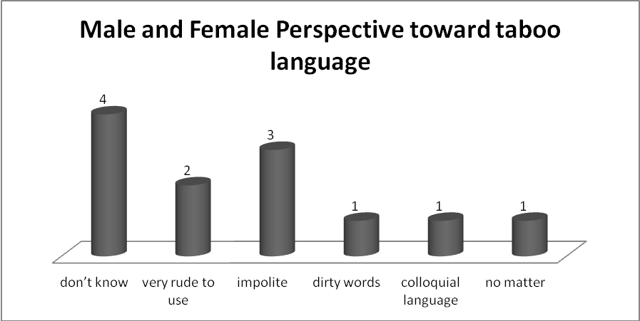
Chart 4.3 Male and Female Perspective on taboo language
The chart above showed that there are two adults believe that taboo language is rude and all people have to avoid to used that language, four adults say she/he doesn't know about it, which is means that they don't have any idea to think about it, in different opinion two of them said that taboo is a kind of dirty words and one other say that taboo in a colloquial language and the last one of them said that taboo is our language that used in daily communication and no matter it is usual to use. From the adult perspective above, it can be divided adults perspective into females and Male below :

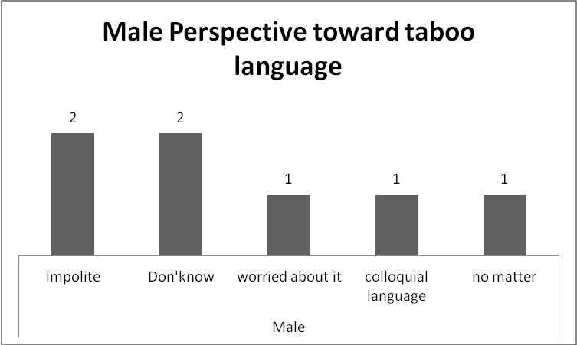
Chart 4.4 Male Perspective toward taboo language
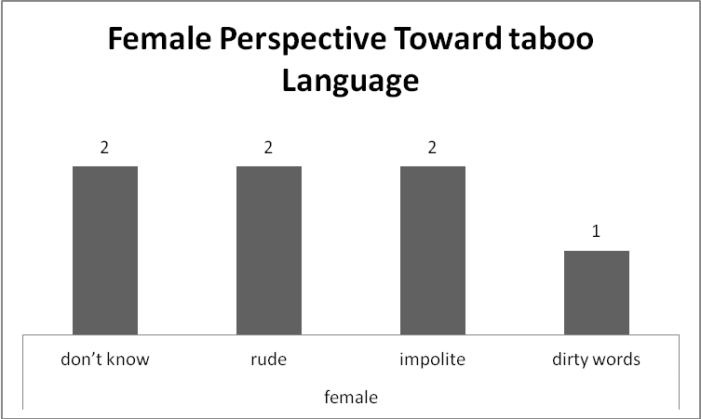
Chart 4.5 Female Perspective Toward Taboo Language
From the chart above it can be compared that females and males almost have the same perspective toward taboo language, as said by R8
“Tidak baik dan ketika tidak sengaja mengucapkannya, maka langsung mengucapkan astagfirullah al azim” ( It is not good if we accidentally used that language, so we have to said “ astagrfirullahal azim ).
Statement from R11 above showed that besides showing his perspective about taboo he also gives away how is avoid in using taboo, But it different with R1, R2, and R10 when researcher ask about perspective about taboo they said that " I don't know related to taboo language". The use of taboo language by all adult below was showed how adult perspective related to taboo language.
Table 4.2 Kinds of Taboo Language that understand by adult ( male and Female)
NO | RESPONDENT |  | Knowloedge about taboo | Taboo language use
1 |  | R1 | I don’t know | I never use and I don’t know about it
2 | FEMALE | R2 | I don’t know | I never use and I don’t know about it
3 |  | R3 | Yes | cursing, insulting other ( paleh, bangai)
4 |  | R4 | Yes | cursing, animal name( bui)
5 |  | R5 | Yes | Name of body ( pek)
6 |  | R6 | Yes | Cursing and insulting:Yak pap ase, bui , paleh
7 |  | R7 | Yes | Kind of animals name ( bui, ase)
8 |  | R8 | Yes | Insulting (Pelacur)
9 | MALE | R9 | Yes | cursing ( pap ma)
10 |  | R10 | I don’t know | I don’t know
11 |  | R11 | Yes | Cursing (lambret ma keuh)
12 |  | R12 | Yes | Bad word (ek kah)
13 |  | R13 | Yes | cursing ( ara kate)
14 |  | R14 | Yes | cursing ( pap ase)

From table above showed that the use of taboos in adolescents above illustrates that the understanding of taboo language in adolescents is only limited dirty words and insults, while according to the concept of Allan and Burridge taboos can be classified into several types, namely: bad language, taboo names and nicknames. , obscenities and unlucky aspects.

5. Conclusion

1. Among males and females ever use taboo language but the most frequently used taboo language is male. Male use more frequency taboo than females, most of the males said that they ever used taboo about fifty-seven percent, in comparing to a female about fourteen percent of them said that ever used taboo language in daily communication.
2. Taboo language that is used by an adult is very limited, adults-only know about the taboo that related to dirty words and insults, this means that taboo that understood by an adult is shifting in belief and practice.
3. Male and Female have the same perspective toward taboo language, most of them believe that taboo is a forbidden word.

References

Ahmad, et.al 2013. A Sociolinguistic Study of the Linguistic Taboos in the Pashtoon Society. International Research Journal, Volume NO.2 Issue No.1 Maret
Allan, and Burridge.2006. Forbidden Words: Taboo and the Censoring of language.
Newyork: Cambridge University Press.
Ali, Faisal. (2013). Identitas Aceh Dalam Perspektif Syari’at dan Adat. Badan Arsip Dan Perpustakaan Aceh. Banda Aceh
Aziz,et.al 2020. Construing Contextual Taboo Words Used by Acehnese Speaker in Indonesia. Journal of Ethnology and Folklristics
Barus, Jumat. 2018. Tabu dalam Bahasa Karo. Dissertation. Doctoral Program in University of Sumatra Utara.
Babou, M.2014, “ A Sociolinguistic Analysis of Use and Perception Insult: Tlemcem Speech Community”.Dalam International Journal of Academic Research and Reflection. Vol 2 No.4 2014. ISSN. 2309-0405
Basov,Ni.et.al .2019. Socio-semantic and other dualities. Poetics, http :// doi.org/101016/j.poetic.2020.101433
Bulusan, Ferdhinan. 2019. College ESL learner's Politenese in Using Taboos and Euphemisme : Looking Through the socio-pragmatic lens. International Journal of English Linguistic Vol 9 no.3 2019
Behzad and Salmani.2017. Translation of taboo words & expressions in Saramago's Blindes. International Journal of Scientific Research ( IJSR).
Bodgan and Biklen.1992. Qualitative Research for Education. United State of America: Allyn and Bacon.
Chiu, C.-Y,et.al. (2010). Intersubjective culture: The role of intersubjective perceptions in cross-cultural research. Perspectives on Psychological Science, 5, 482-493.
Duranti, Alessandro.1997. Linguistic Antropology. Newyork: Cambridge University Press.
Douglas, M.1966. Purity and Danger: An Analysis of the Concepts of Pollution and Taboo.London and Newyork : Routdlege.
Fakhri.L.J,2019. The Nature, Types, Motives and Functions of Swear Words: A sociolingustic Analysis.International Journal Of Development Research. Vol 09 Issu 4. Website: http://www. Journalidjdr.com.
Fernandes E.Crespo.2011. “Conceptual Metaphor in Taboo-Induces Lexical Variation.” Dalam Revista Alicantina de Estudios Ingleses. 24 ( 2011) Dalam http://rua.ua.es/dspace/bitstream/10045/22598
Frazer, Sir Jim George .1913/1980.Taboo and the Perils of the Soul . London : Macmilan & Co Ltd.
Freud, Sigmund.1913. Totem and taboo (translated by james Stratchey 2004.London and Newyork: Roulegde.
Gabriel and charlotte. 2021. Taboo and euphemistic Idiom in Ejaghan: Sociopragmatic analysis. Scholar International Journal of Linguistics and Literature
Ghounane, Nadia. 2014. A Sociolinguistic View of Linguistic Taboos and Euphemistic Strategies in the Algerian Society: Attitudes and Beliefs in Tlemcen Speech Community. International Journal of Research in Applied Natural and Social Science, Volume 2, 73-88
Gao,Chamming,2014.Sociolinguistic Study of English Taboo Language. Journal of Theory and practice in Language studies, Vol 3 No.12. Academic publisher. Finland.
Hasnandar. M.2018. Social Identity and Use of Taboo Words in Angry Mood: A Gender Study. Journal of Theory and Practice in Language Studies vol. 8. No.6 , pp 623-628.
Harun.,et.al.2019. Taboo Language on physical and Mental Limitation in the pidie raya community. English education Journal . ( EEJ ) 10. (4) 321-342
Hansen.,et.al.2019. The neurobiology of taboo language processing : FMRI evidence during spoken words production. Social cognitive and affective neuroscience.
Herniti, Ening.2014. Sapaan Dalam Ranah Keagamaan Islam (Analisis Sosiosemantik). Journal Thaqãfiyyãt, Vol. 15, No. 1, 2014
Holmes, Janet. 2013. An Introduction to Sociolinguistics. New York : Routledge
Houssaini,K.2019. A sociolinguistic Approach of Taboo words in Morrocan Society, European Scientific Journal , Vol 15 no 29.
Hysi.E.2011. Aspect of Taboos and Euphemisms in Women's Language.Mediterranean Journal of Social Sciences. Vol.2 No.3 September 2011.
Jay, Timothy. 2009. The Utility and Ubiquity of Taboo Words. Perspectives on Psychological Science, Volume 4, 153-161
Jay, Timothy and Janschewitz, Kristin.2008. " The Pragmatics of swearing" Dalam journal of politeness research.4 (2008) Dalam http://www.edu/Assest/MCLA-Files/Academics/ Undergraduate / Psychology/pragmaticswearing.pdf.
Jay, Timothy.2000. “Why we curse” Philadelphia: John Benjamin Publishing.
Jay,et.al.2006. Memories of Punishment for cursing. Springer Science. The utility and ubiquity of taboo words
Javad,et.al.2014.Gender Tendency toward using taboo words among University Students
Junaidi and Wardani.2019. Konteks Penggunaan Bahasa Tabu Sebagai Pendidikan Etika Tutur Dalam Masyarakat Pidie. Jurnal Serambi Ilmu, Volume 20, Nomor 1, Edisi Maret 2019
Kurdi, Muliadi.2005. Menelusuri Karakteristik Masyarakat Aceh, Pendekatan Sosiaologi Budaya Dalam Masyarakat Aceh. Banda Aceh. Yayasan Pena

De,V,K.1992 . How Taboo are taboo words for girls?. Language in Society. Cambridge University Press

Kridalaksana, Harimurti. Kamus Linguistik. Jakarta: PT Gramedia

Lakoff, Robin. 1973. Language and Woman’s Place. Language in Society, Vol. 2, 45-80

Laksana, I ketut Darma. 2009. Tabu Bahasa salah satu cara memahami kebudayaan Bali. Denpasar: Udayana University Press.
Liedlich R.D. (1973). Coming to terms with language: an anthology, New York: Wiley.
Ljung, Magnus.2011.Swearing: A Cross- Cultural Linguistik Study. Sweden: Pargrave Macmilan
Mahsun. 2005. Metode Penelitian Bahasa: Tahapan Strategi, Metode dan Tekniknya.Jakarta: PT Raja Grafindo Persada
Mutia,et.al. 2018. Deskripsi Bahasa Tabu Dalam Masyarakat Teunom Kabupaten Aceh Jaya. Jurnal Ilmiah Mahasiswa Jurusan PBSI Vol. 3 No. 2 ; Mei 2018:103-114.
Meyerhoff, Miriam. 2006. Introducing Sociolinguistics. New York : Routledge
Milroy, L. and Gordon, M. 2003. Sociolinguistics. Oxford : Blackwell Publishing
Mocanu,Mihaela.2016. Taboo and Euphemism in the Religiouse Language. Interational Journal of Social and Humanistic Science, ISSN:2300-2697,Vol.75.pp 1-9, doi: 1018052/www.Scipress.com/ILSHS.75.1 2017 SciPress Ltd, Switzerland.
Nella et.al. 2019. “Don’t Sweep the Floor!” Verbal and Nonverbal Taboo in Nagan Raya, Aceh. Studies in English Language and Education (SIELE UNSYIAH), 6(2), 309-318, 2019
Rai, C.A and Yidampoa, G.G.2020. Gender and Sexuality Linguistic Taboos : A Case of Mo and Nnyabi in Ewe and Mumpulli. Hybrid Journal of Literacy and Cultural Studies. Volume, 2 Issue 3.2020.
Saber, et.al.2020, An investigation into the effect of foreign language learning onn the use of taboo words in the learners' first language discourse. eaching English language , Vol.14,No.1, winter spring
Salzman, Z. Language, Culture & Society. Boulder. Westview Press Inc,1993.
Sutarman.2013. Tabu Bahasa dan Eufemisme. Surakarta : Yuma Pustaka

Sudaryanto. 2015. Metode dan Aneka Teknik Analisis Bahasa. Yogyakarta:Sanata Dharma University Press.
Pilotti.et.al. 2012. Taboo words in Expressive Language: Do Sex and Primary Language Matter?. American International Journal of Contemporary Research.
Rahmani, et.al.2019. Types and Functions of Linguistic Taboos in Iranian Movies. Journal of Language and horizon, Alzahra University. Iran.
Roest, et.al. 2018. Ducth Taboo Norms. Springerlink.com
Rosenberg, et.al.2017. The afective behavioural cognitive of taboo words in natural language :the relationship between taboo words intensity and Frequency. ournal of language and social psychologi
Spraedly.1980. Participant observation. USA.Hartcourt Brace Jovanovich College Publisher.
Stephan and Uhlaner, 2010. Performance-based vs socially supportive culture: A cross-national study of descriptive norms and entrepreneurship. Journal of International Business Studies, 41, 1347-1364
Shteynberg, et.al. (2009). Peering into the “magnum mysterium” of culture.
Journal of Cross-Cultural Psychology, 40, 46-69.
Trudgill.P.1983. Sociolinguistic: An Introduction to Language and society.London. Penguin Book.
Trudgill.P.2021. Sex. Covert prestge and linguistic change in the urban British English of Norwich. Cambridge.Great Britain.
Uhlman,Kathleen M..2015. Use and Perception of Taboo Language in College Age Females. Honor Thesis and Capstone,227 http://Scholars.unh.edu/honors/227.
Uzdu. Funda,y.2021. use of euphemisms in youth language. Journal of language and linguistic studies ( Q2)
Wardhaugh, Ronald&Fuller, Janet M. 2015. An Introduction to Sociolinguistics. Sussex: Wiley Blackwell
Wardhaugh, Ronald. 2006. An Introduction to Sociolinguistics. Fifth edition Oxford: Blackwell Publishing
Wardhaugh, Ronald. 2010. An Introduction to Sociolinguistics. Sixth edition. Oxford: Blackwell Publishing
Wodak, R. 1997. Language and Discourse. London, SAGE Publications Ltd.

Xiago, Zhang and Qian Ma. 2017. An analysis on Dynamic and Static Aspect of Language Taboo from Cross-Cultural Perspective. social sciences Vol 6, No.4 2017 pp.123-126
Yau, Andrew. 2011. Are you superstitious? a survey on Chinese attitudes towards homophonic word taboo. International Journal of Art and science.

Zahra and Robati.2017. Translation of taboos: The Absolutely True Diary of Part-time Indian. International Journal of Applied Linguistics & English Literature

Zhao and Zhang.2016. Interpersonal Function o the Linguistic Taboo. 2nd International Conference on Economy, Management and Education Technology (ICEMET 2016). Atlantis Press.China

Zhang Y ( 2017) .Study on the present study situation of Japanese taboo. Paper presented at the international conference on humanities, arts, and language retrieved fromhttps://webof proceedings-series/ESP/HUM/AL

