No. | Statements | Answers
 |  | Strongly Agree |  | Agree |  | Neutral |  | Disagree |  | Strongly Disagree
 |  | % | Total | % | Total | % | Total | % | Total | % | Total
1. | S1 | 44.4 | 8 | 50 | 9 | 5.6 | 1 | 0 | 0 | 0 | 0
2. | S2 | 27.8 | 5 | 50 | 9 | 22.2 | 4 | 0 | 0 | 0 | 0
3. | S3 | 27.8 | 5 | 44.4 | 8 | 27.8 | 5 | 0 | 0 | 0 | 0
4. | S4 | 22.2 | 4 | 55.6 | 10 | 16.7 | 3 | 0 | 0 | 5.6 | 1
5. | S5 | 16.7 | 3 | 55.6 | 10 | 27.8 | 5 | 0 | 0 | 0 | 0
6. | S6 | 11.1 | 2 | 72.2 | 13 | 16.7 | 3 | 0 | 0 | 0 | 0
7. | S7 | 16.7 | 3 | 66.7 | 12 | 11.1 | 2 | 5.6 | 1 | 0 | 0
8. | S8 | 16.7 | 3 | 38.9 | 7 | 27.8 | 5 | 16.7 | 3 | 0 | 0
9. | S9 | 16.7 | 3 | 55.6 | 10 | 11.1 | 2 | 16.7 | 3 | 0 | 0
10. | S10 | 16.7 | 3 | 55.6 | 10 | 11.1 | 2 | 16.7 | 3 | 0 | 0
11. | S11 | 27.8 | 5 | 55.6 | 10 | 5.6 | 1 | 11.1 | 2 | 0 | 0
12. | S12 | 27.8 | 5 | 44.4 | 8 | 22.2 | 4 | 5.6 | 1 | 0 | 0
13. | S13 | 33.3 | 6 | 55.6 | 10 | 11.1 | 2 | 0 | 0 | 0 | 0
14. | S14 | 27.8 | 5 | 55.6 | 10 | 16.7 | 3 | 0 | 0 | 0 | 0
15. | S15 | 22.2 | 4 | 61.1 | 11 | 11.1 | 2 | 5.6 | 1 | 0 | 0
16. | S16 | 27.8 | 5 | 61.1 | 11 | 11.1 | 2 | 0 | 0 | 0 | 0
17. | S17 | 27.8 | 5 | 50 | 9 | 22.2 | 4 | 0 | 0 | 0 | 0
 | Total | 0 | 74 | 150 | 167 | 0 | 50 | 0 | 14 | 0 | 1

APPENDICES

QUESTIONNAIRE
Statement for Questionnaire
- I know Google Classroom.
- I know how to operate Google Classroom well.
- I can organize the class on Google Classroom.
- Google Classroom is one of the online learning systems that I use to assess students’ learning activity.
- Assessing students’ learning activity is easier while using Google Classroom.
- Google Classroom is effective in assessing students’ learning activity.
- I have experience in using Google Classroom while assessing students’ learning activity.
- I assess students in the beginning of learning activity through Google Classroom.
- I assess students during the learning activity through Google Classroom.
- I assess students in the end of learning activity through Google Classroom.
- I share the material for learning activity through Google Classroom.
- I share the assignment for learning activity through Google Classroom.
- Google Classroom can help me in learning activity.
- Google Classroom is effective for doing the learning activity.
- The use of Google Classroom gives me benefit in assessing students’ learning activity.
- Google Classroom helps me in assessing students’ learning activity.
- I recommend the use of Google Classroom for the other teachers while assessing students’ learning activity.

Table of Questionnaire’s Result
No. | Statements | Answers
 |  | Strongly Agree |  | Agree |  | Neutral |  | Disagree |  | Strongly Disagree
 |  | % | Total | % | Total | % | Total | % | Total | % | Total
1. | Statement 1 | 44.4 | 8 | 50 | 9 | 5.6 | 1 | 0 | 0 | 0 | 0
2. | Statement 2 | 27.8 | 5 | 50 | 9 | 22.2 | 4 | 0 | 0 | 0 | 0
3. | Statement 3 | 27.8 | 5 | 44.4 | 8 | 27.8 | 5 | 0 | 0 | 0 | 0
4. | Statement 4 | 22.2 | 4 | 55.6 | 10 | 16.7 | 3 | 0 | 0 | 5.6 | 1
5. | Statement 5 | 16.7 | 3 | 55.6 | 10 | 27.8 | 5 | 0 | 0 | 0 | 0
6. | Statement 6 | 11.1 | 2 | 72.2 | 13 | 16.7 | 3 | 0 | 0 | 0 | 0
7. | Statement 7 | 16.7 | 3 | 66.7 | 12 | 11.1 | 2 | 5.6 | 1 | 0 | 0
8. | Statement 8 | 16.7 | 3 | 38.9 | 7 | 27.8 | 5 | 16.7 | 3 | 0 | 0
9. | Statement 9 | 16.7 | 3 | 55.6 | 10 | 11.1 | 2 | 16.7 | 3 | 0 | 0
10. | Statement 10 | 16.7 | 3 | 55.6 | 10 | 11.1 | 2 | 16.7 | 3 | 0 | 0
11. | Statement 11 | 27.8 | 5 | 55.6 | 10 | 5.6 | 1 | 11.1 | 2 | 0 | 0
12. | Statement 12 | 27.8 | 5 | 44.4 | 8 | 22.2 | 4 | 5.6 | 1 | 0 | 0
13. | Statement 13 | 33.3 | 6 | 55.6 | 10 | 11.1 | 2 | 0 | 0 | 0 | 0
14. | Statement 14 | 27.8 | 5 | 55.6 | 10 | 16.7 | 3 | 0 | 0 | 0 | 0
15. | Statement 15 | 22.2 | 4 | 61.1 | 11 | 11.1 | 2 | 5.6 | 1 | 0 | 0
16. | Statement 16 | 27.8 | 5 | 61.1 | 11 | 11.1 | 2 | 0 | 0 | 0 | 0
17. | Statement 17 | 27.8 | 5 | 50 | 9 | 22.2 | 4 | 0 | 0 | 0 | 0
 | Total | - | 74 | - | 167 | - | 50 | - | 14 | - | 1

INTERVIEW
Interview Guideline
- Apakah anda menggunakan Google Classroom sebagai media untuk kegiatan pembelajaran di kelas online?
- Mengapa anda menggunakan Google Classroom untuk menilai kegiatan belajar siswa di masa pandemi COVID-19?
- Bagaimana cara anda menilai kegiatan belajar siswa dengan menggunakan Google Classroom?
- Bentuk tugas seperti apa yang biasanya atau sering anda gunakan untuk menilai siswa dalam kegiatan belajar melalui Google Classroom?
- Benuk penilaian seperti apa yang biasanya atau sering anda gunakan untuk menilai siswa dalam kegiatan belajar melalui Google Classroom?
- Apakah anda memiliki kendala dalam menilai kegiatan belajar siswa melalui Google Classroom? Bila ya, apa saja?
- Apakah anda merekomendasikan penggunaan Google Classroom dalam menilai kegiatan belajar siswa?

DOCUMENTATION
Interview Video Recording (Virtual Zoom Meeting)

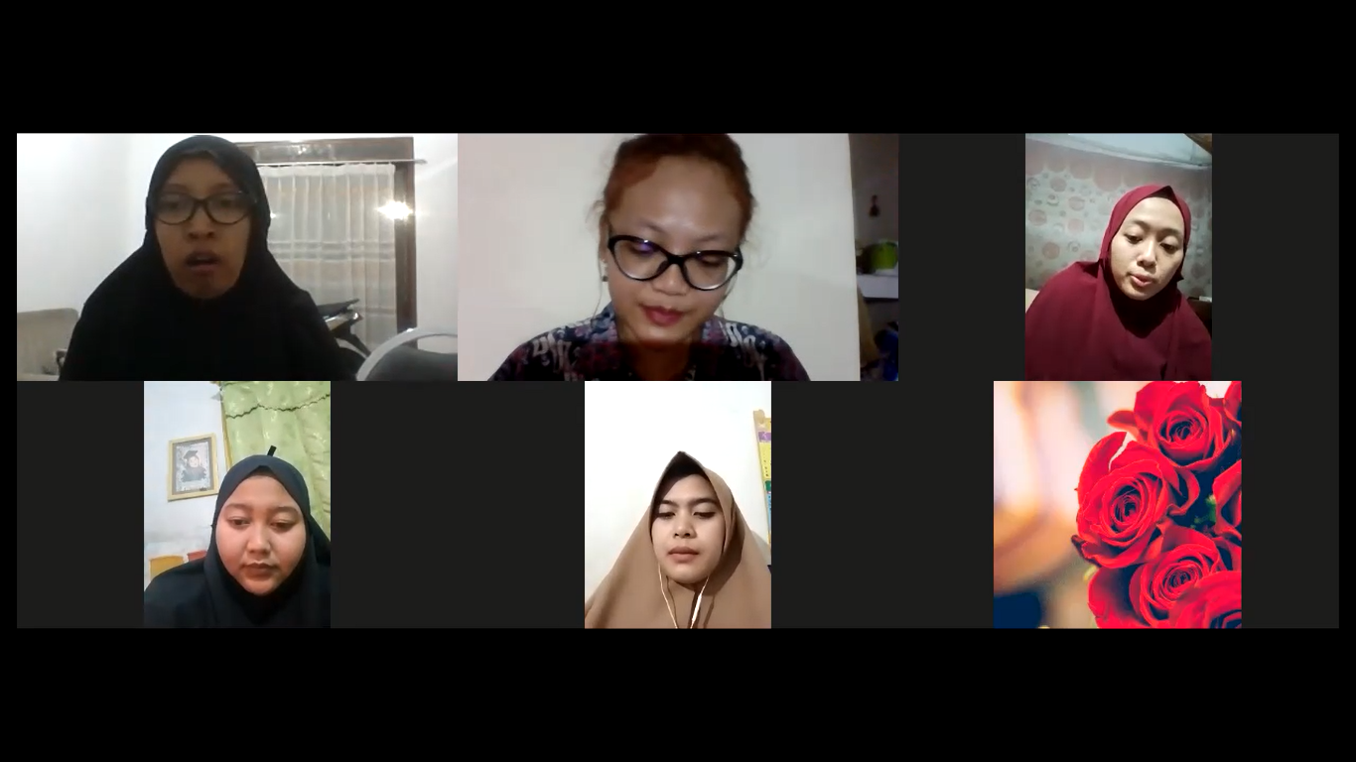
No. | Statements | Answers
 |  | Strongly Agree % | Agree % | Neutral % | Disagree % | Strongly Disagree %
 |  | % | % | % | % | %
1. | S1 | 44.4 | 50 | 5.6 | 0 | 0
2. | S2 | 27.8 | 50 | 22.2 | 0 | 0
3. | S3 | 27.8 | 44.4 | 27.8 | 0 | 0
4. | S4 | 22.2 | 55.6 | 16.7 | 0 | 5.6
5. | S5 | 16.7 | 55.6 | 27.8 | 0 | 0
6. | S6 | 11.1 | 72.2 | 16.7 | 0 | 0
7. | S7 | 16.7 | 66.7 | 11.1 | 5.6 | 0
8. | S8 | 16.7 | 38.9 | 27.8 | 16.7 | 0
9. | S9 | 16.7 | 55.6 | 11.1 | 16.7 | 0
10. | S10 | 16.7 | 55.6 | 11.1 | 16.7 | 0
11. | S11 | 27.8 | 55.6 | 5.6 | 11.1 | 0
12. | S12 | 27.8 | 44.4 | 22.2 | 5.6 | 0
13. | S13 | 33.3 | 55.6 | 11.1 | 0 | 0
14. | S14 | 27.8 | 55.6 | 16.7 | 0 | 0
15. | S15 | 22.2 | 61.1 | 11.1 | 5.6 | 0
16. | S16 | 27.8 | 61.1 | 11.1 | 0 | 0
17. | S17 | 27.8 | 50 | 22.2 | 0 | 0
 | Total | 24 | 50 | 16 | 4 | 6

